**The Tweetables**

**Ada Bulgur, Amir Crutchfield, Sydney Johnson, Micaiah Steplight, Isaac Stinnette**



**Project Plan**

**Table of Contents**

**1.0 Project Overview 3**

**1.1 Objective 3**

**1.2 Scope 3**

**2.0 Management 4**

**2.1 Communication and Meetings 5**

**3.0 Timeline/ Schedule 6**

**3.1 Iteration 1 6**

**3.2 Iteration 2 7**

**3.3 Iteration 3 8**

**3.4 Iteration 4 9**

**3.5 Iteration 5 10**

**3.6 Final Presentation 11**

**4.0 Test Schedule 12**

**5.0 Resource/Tools 13**

**6.0 Risk Management 14**

**6.1 Key Infrastructure 14**

**6.2 Predicted Threats 14**

**6.3 Vulnerabilities, Risks, and Mitigation 14**

**7.0 Restrictions, Limitations, & Constraints 16**

**7.1 Restrictions 16**

**7.2 Limitations 16**

**7.3 Constraints 16**

**8.0 Revision Log 17**

# 

# **1.0 Project Overview**

## **1.1 Objective**

The goal of the project is to create a running application that will help corporations determine the emotional tone of a selected product. The application will do this by sorting people’s feelings for a product into three different categories. These categories are positive, negative and neutral.

## **1.2 Scope**

Tweetables plans to use a Lexicon-based approach in order to build a Sentiment Analysis application. This will be done by using APIs from X in order to build a Lexicon-Based dictionary that will be used to measure people’s emotional tone towards a product. The application will include components that will allow it to gather data, clean data, analyze data and then display the results of the data. Our application will not be using any ML-based techniques. A synopsis of the tasks that must be completed to create the application are:

* Utilize X’s APIs in order to gather data.
* Implement data cleaning so that the analysis focuses only on meaningful words.
* Implement Lexicon-Based sentiment analysis within the application so that certain words get tagged with the correct polarity (positive, negative, or neutral).
* An installation script be provided to install the app, so that the app can be executed with a single click on the installed file.

# **2.0 Management**

All members have been assigned their roles and deliverables to complete. The members' strengths and weaknesses were considered when deciding on various roles. Sydney Johnson was appointed as Project Manager (PM) by Dr. Muhammad and Dr. Chitteenden. Micaiah Steplight was assigned to be Assistant Project Manager, and the following roles were assigned to the group, Programming Lead, Document Lead, and Testing Lead.

| Roles | Members Assigned | Description |
| --- | --- | --- |
| Project Manager | Sydney Johnson | Responsible for the overall planning, execution, and delivery of a project. The role involves managing resources, setting project timelines, coordinating team members, liaising with stakeholders, and mitigating risks. |
| Assistant Project Manager | Micaiah Steplight | Supports the Project Manager in planning and executing project tasks. The APM helps coordinate resources, track project progress, and handle administrative duties. They may take on smaller parts of the project independently or work closely with the PM |
| Programming Lead | Ada Bulgar | Responsible for overseeing the technical development and coding aspects of a project. They lead the programming team, ensuring that the code meets project requirements, adheres to standards, and is delivered on time |
| Document Lead | Isaac Stinnette | Responsible for managing all the documentation needs of a project, ensuring that all required documentation (e.g., technical documents, user manuals, project plans) is accurate, up-to-date, and easily accessible. |
| Testing Lead | Amir Crutchfield | Responsible for planning and executing a comprehensive testing strategy. They oversee the creation and execution of test cases, defect management, risk mitigation, and reporting on quality metrics, ensuring the software meets requirements and standards. |

# 

## **2.1 Communication and Meetings**

* Weekly meetings will be held 1-3 times a week based on the project’s necessities. Meetings will be held after CSC 405 on Tuesdays and Thursdays. All team members: Sydney Johnson, Micaiah Steplight, Ada Bulgar, Isaac Stinnette, and Amir Crutchfield are expected to attend the group meetings. At group meetings, we will work together on enhancing the product and documentation. All in-person group meetings will be held in S&T room 127 or S&T room 320.
* Group messaging: Team members will communicate with updates, scheduling, and reminders via iMessage.

# **3.0 Timeline/ Schedule**

## **3.1 Iteration 1**

**Dates:** January 9, 2025 – January 23, 2025

**Tasks:**

* Assign team roles and objective
* Assess team members' strengths and weaknesses
* Finalize our chosen website to conduct sentiment analysis
* Evaluate project and create Requirements Document
* Create Project Plan on Jira or other project planning software’s
* Complete meeting minutes & Time Log

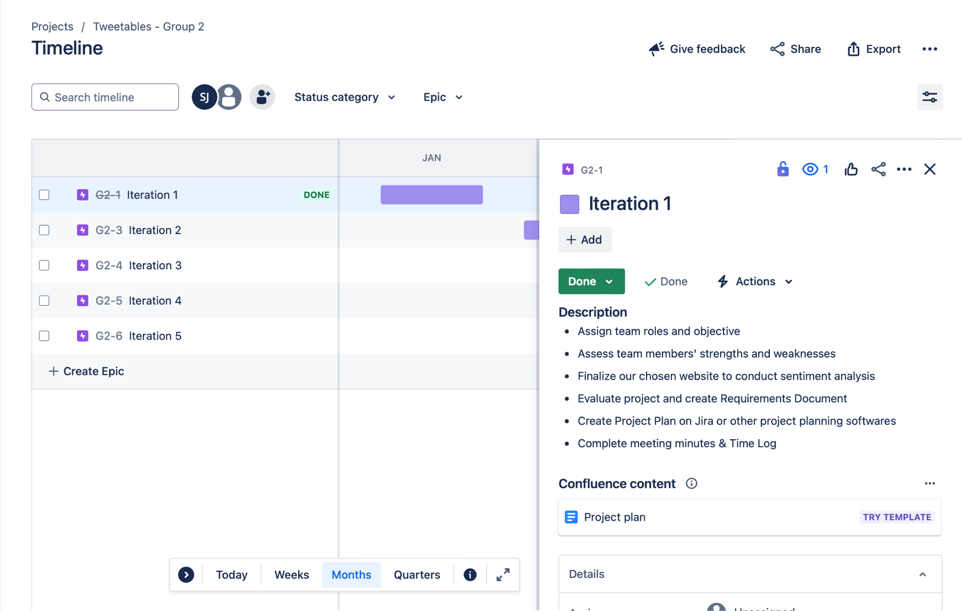

## 

## **3.2 Iteration 2**

**Dates:** January 24, 2025 - February 13, 2025

**Tasks:**

* Create Functional Specification Document.
* Developing sequence, activity, data-flow, and state diagrams
* Start on the overall Architecture design.
* Create an early version of a Design Specification document
* Develop initial prototypes to verify your understanding of the assignment.
* Update the Requirements Document and Project Plan to reflect the changes made in this iteration

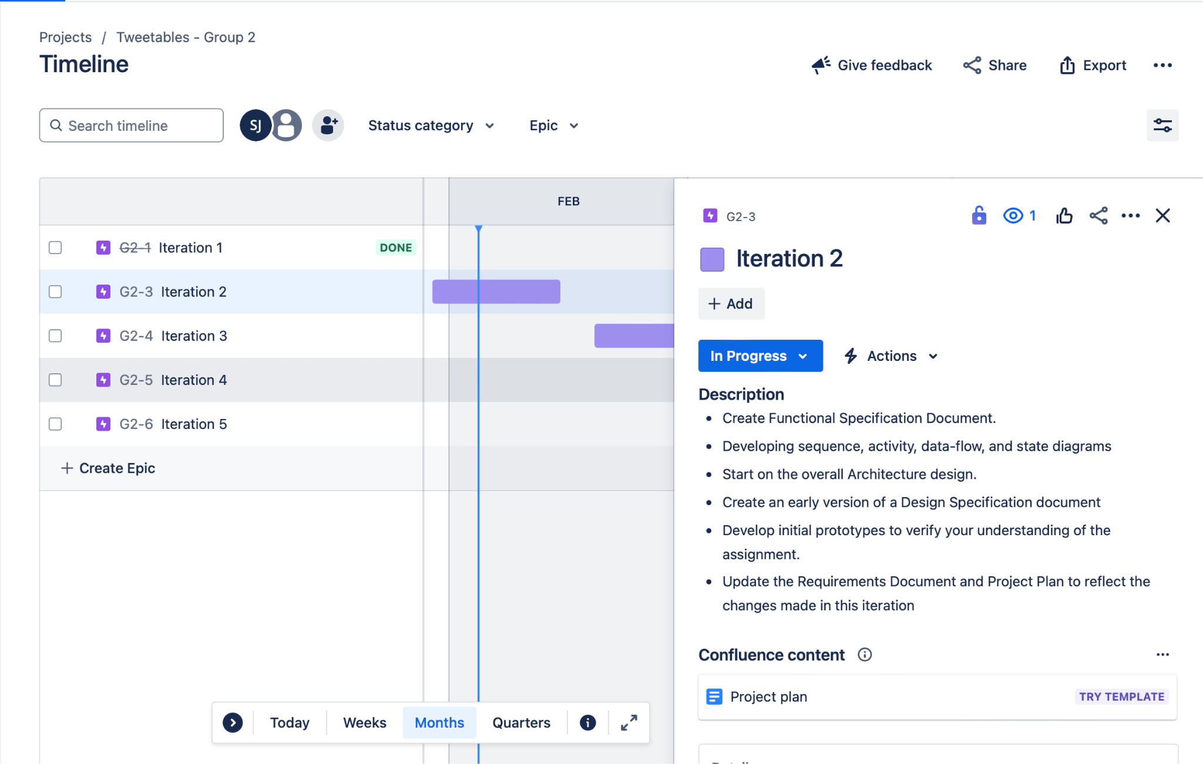

## 

## 

## **3.3 Iteration 3**

**Dates:** February 14, 2025 – March 6, 2025

**Tasks:**

* Create Test Specifications Document
* Focus shifts to the Design Specification.
* Complete the overall Architecture design.
* Initial prototypes now become an early version of the product.
* Updated previously created documents to reflect changes in this iteration

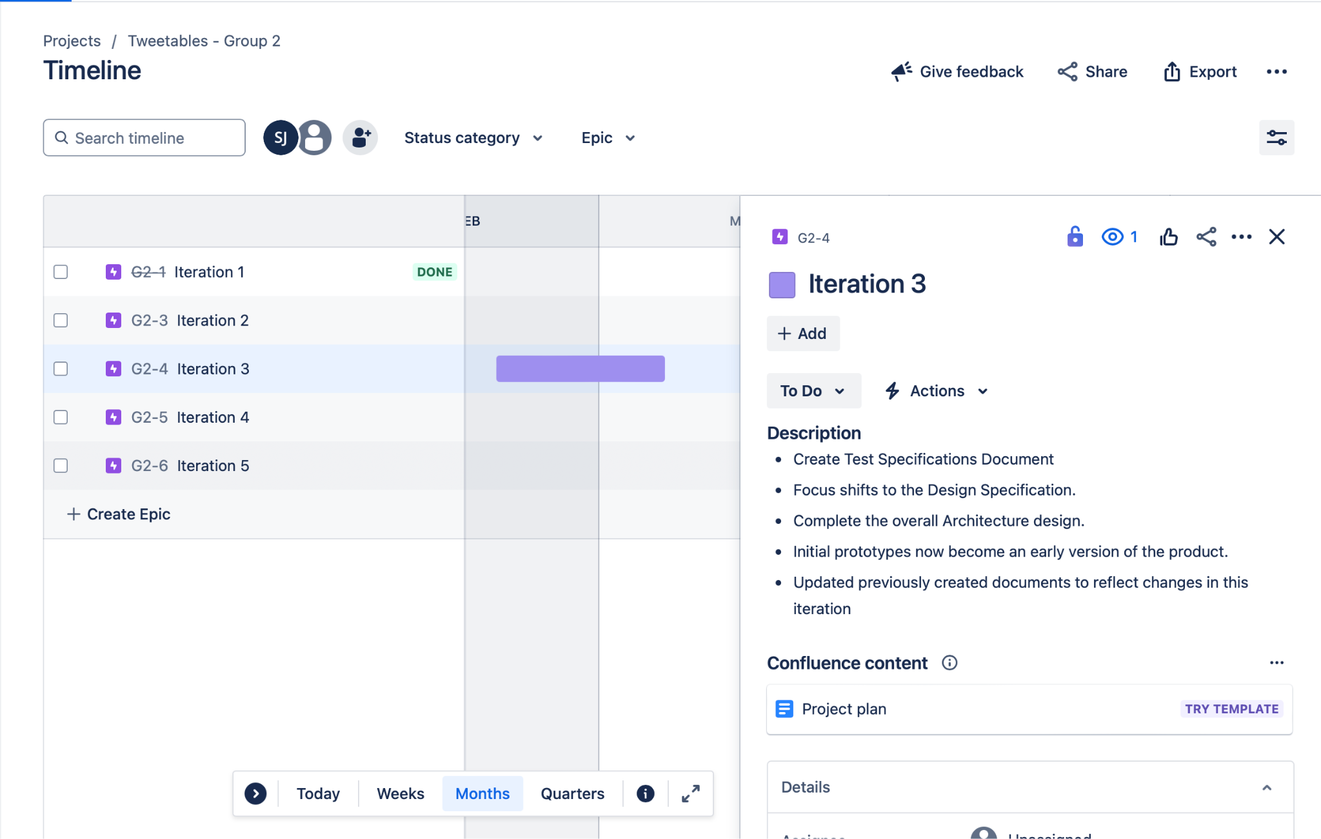

## 

## 

## **3.4 Iteration 4**

**Dates:** March 7, 2025 – March 27, 2025

**Tasks:**

* This iteration is all about Product.
* The Design Specifications should be largely completed.
* Focus shifts to the Product and the Test Specification.
* Early versions of the Product now become a Beta Release of the product and should include a Readme as to how to install and run the product.
* Formal deliverables are the Beta Release of the Product and the Test
* Updated versions of all the Documents that reflect changes as the project evolves should also be submitted.

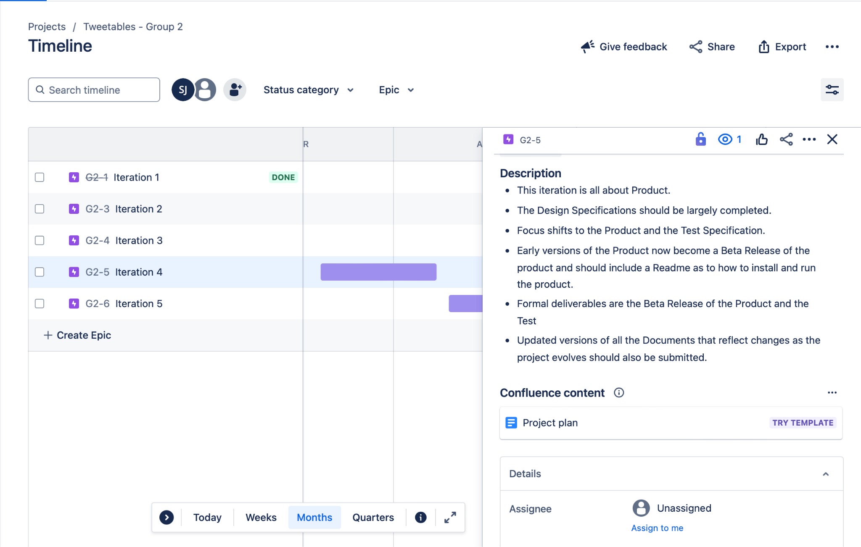

## **3.5 Iteration 5**

**Dates:** March 28, 2025 – April 22, 2025

**Tasks:**

* This iteration is all about Product.
* The Test Specifications should be largely completed.
* Focus shifts to the Product and Testing.
* Early versions of the Product now become a Release Candidate of the product.
* Formal deliverables are the Release Candidate of the Product and the complete set of Documentation for the project.
* Updated versions of all the Documents that reflect the Final Product should be submitted.

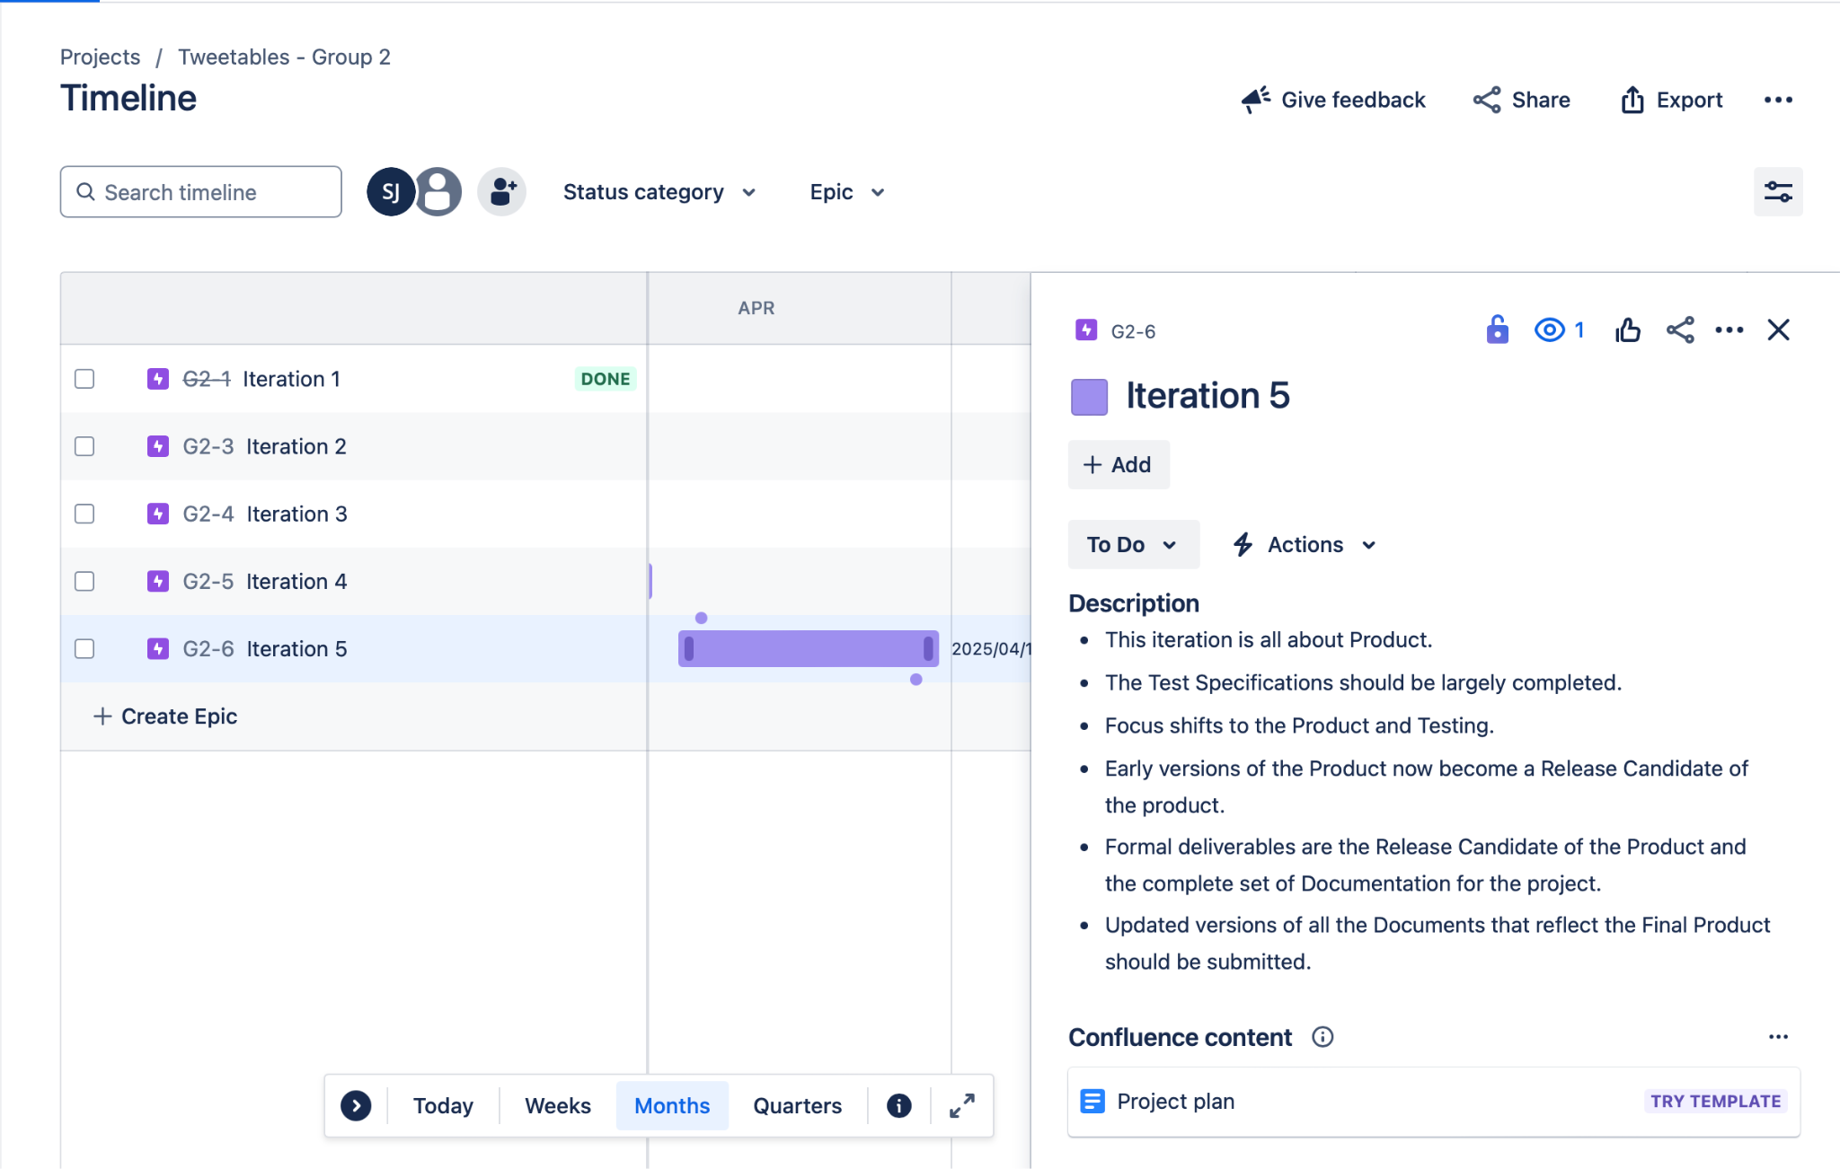

## 

## 

## **3.6 Final Presentation**

**Dates:** April 29, 2025

**Tasks:**

* **Present prototype and final documents to customer**

## 

# **4.0 Test Schedule**

# 

# **5.0 Resource/Tools**

**JIRA:** Project management and issue tracking tool developed that is widely used for agile project management, tracking bugs, and managing tasks in software development and other projects.

**Python:** Object-oriented programming language we are using to code the application.

**Google Drive:** Cloud based storage used to store all documents, time logs and meeting minutes. The group can collaborate and share as needed.

**Visual Studio:** Created by Microsoft. It is used for writing, debugging, and testing code in various programming languages, including C#, C++, Python, and more.

**X’s API:** A valuable resource used to gather real-time tweets based on user-specified keywords, hashtags, or mentions. This will allow the system to analyze current sentiment related to a specific product or subject.

**Laptops:** Portable personal computers used by professionals for various tasks, including development, communication, documentation, and more

**Cellular Device**: A cellular device (e.g., smartphone) is a mobile communication device that allows users to make phone calls, send text messages, and access data through the cellular network.

# **6.0 Risk Management**

Recognizing, evaluating, and averting possible risks that can jeopardize the success of the project. Technical problems, resource constraints, security flaws, and scope modifications are typical hazards. Teams can identify high-risk areas and establish mitigation techniques, such as contingency planning, regular monitoring, and adopting agile methodologies to manage shifting difficulties, by analyzing each risk based on its likelihood and impact. Good risk management guarantees that the project stays on schedule, stays under budget, and satisfies quality requirements.

## **6.1 Key Infrastructure**

Software

* Visual Studios
  + Python
  + CSS
  + HTML
* Google Drive
* X API’s
* Jira (forecasting)

Hardware

* Personal Computers
* Desktops

## **6.2 Predicted Threats**

* Inconsistent Data
* High volume of data

## **6.3 Vulnerabilities, Risks, and Mitigation**

Vulnerabilities

* Data limitations: We are limited to access 1500 Tweets per month and don’t have access to data older than 7 days. This can potentially cause incomplete data sets and non-representative data which will distort our results.
* Rate limits: Controls the amount of request for data a user can make in a certain timeframe. This could lead to potential gaps in data.
* Data Quality: Data quality is a crucial factor that directly impacts the accuracy and reliability of the results. Poor data quality can create vulnerabilities, leading to skewed analyses and unreliable insights.

Risks

* Sampling Bias: When sampled data is heavily biased this could lead to inaccurate insights and flawed conclusions about action movies of 2024. Recognizing and addressing these biases are critical to guarantee reliable analysis.
* Ethical & Legal risks X has strict guidelines regarding data usage. It's imperative to follow these guidelines when conducting our analysis to respect user privacy.

Mitigation

* Data Cleaning: Proper data cleaning involves removing duplicates and filtering out irrelevant data to highlight the important data. This is essential for ensuring that your sentiment analysis project is built on high-quality, accurate, and relevant data.
* Securing Data: Implementing encryption and data access controls when handling data.
* Handling rate limits: Implement rate-limiting mechanisms in your application to avoid exceeding API request thresholds.

# 

# **7.0 Restrictions, Limitations, & Constraints**

## **7.1 Restrictions**

* Due to the strict time limits, it is possible that some jobs will be completed hurriedly or incompletely to ensure that everything is finished by the planned delivery date.
* X’s API free tier: While X’s free API tier will allow us to access the data, we need to successfully complete a sentimental analysis there are restrictions like a monthly tweet retrieval limit at 1500 tweets a month and there are also data storage limitations.

## **7.2 Limitations**

* Data limitations: There are limitations to the amount of data we can fetch due to the API’s free tier restrictions. Also, there is potential bias in data on X making it difficult to detect tweets that are serious or trolls.
* Model limitation: Our model could struggle sensing sarcasm in Tweets making it difficult to tell if certain words have a positive or negative tone.

## **7.3 Constraints**

* Incomplete Data: A major feature of X is threads which are connected tweets that allows users to add more context past the 280-character limit. When fetching data, only reviewing one part of a thread could lead to missing context which will negatively impact our sentimental analysis.
* Time: To reach our project's deadline, we're employing timesheets to keep our team organized and on track. To ensure the project is completed as quickly as possible, several team members who are proficient in Python are splitting up the coding responsibilities among themselves.

# **8.0 Revision Log**

| Version | Date | Document |
| --- | --- | --- |
| 1.0 | 1/24/2025 | Project Plan Document Version 1.0 |
| 2.0 | 2/13/2025 | Project Plan Document Version 2.0 |
| 3.0 | 3/6/2025 | Project Plan Document Version 3.0 |
| 4.0 | 3/27/2025 | Project Plan Document Version 4.0 |
| 5.0 |  | Project Plan Document Version 5.0 |